SPARK: Simple Play Adaptations to Reference for Kids

SuperTalker FT
Description: | Image:
The SuperTalker FT is multiple message static display augmentative and alternative communication (AAC) speech device that can assist children who need speech support throughout their daily activities.  The device comes with 4 grids which allow the device to be configured into 1, 2, 4, 8 single message cells. A message is recorded on each cell with pictures and/or words that represent the message added to a paper overlay that is inserted over the message cells. Total record time of all messages combined on the device is 16 minutes.  Additionally, the device also has 8 levels which allows messages to be stored and quickly used with the change of the level and the corresponding message overlay for a total of 64 different messages (only 8 messages can be displayed at a time. The device also features 8 ports to attach up to 8 switches simultaneously making the device switch accessible for those users who do not have the motor ability to activate the Super Talker cells.  While this device is switch accessible, it does not provide switch scanning of cells; rather each cell needs an individual switch plugged into the corresponding port to activate the cell message. Two toy ports also allow toys to be attached to the device. When the cell or switch is activated a spoken message is played and the toy is turned on. | 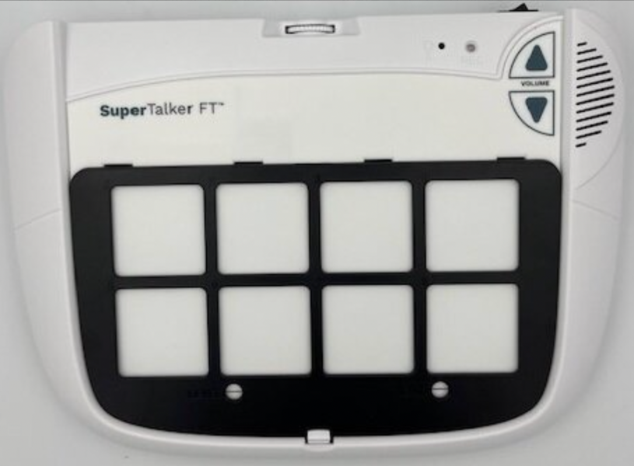  Purchasing Information  Users Manual and Other Resources  Basic Features Video  Advanced Features Video

Who Might Benefit?
Those who…
• have unreliable speech or are difficult to understand.
• have difficulty expressing ideas, feelings, needs, wants.
• exhibit frustration or anger because others are unable to understand their communication attempts.
• struggle socially with peers because of communication difficulties.
• have difficulty understanding only oral directions given by others.
• have difficulty understanding and completing multi-step activities (schedules, routines, directions).
• have adequate fine motor skills to isolate a finger to poke the communication cell or press a switch to activate the device.

Why Use?
Provides an opportunity to…
• Comment more effectively to others.
• Engage in multiple shared communication exchanges.
• Hear verbal directions paired with a visual cue as many times as needed.
• Make choices.
Instructions for Use: | Adaptation Ideas:
Environmental Considerations  - Easily use in almost any environment, easily transportable due to small size, weight (33.6-oz).  - While the SuperTalker FT has good quality digital recording and play back of messages, it may still be difficult for some communication partners to hear in unusually loud environments.  - Users will need to learn when it is appropriate to use the device in quiet environments in the same way that children who are speakers learn when they need to talk or not talk in quiet environments.  - If the device is used as a part of a child's total communication system it should be available in all the child's environments, at all times, and without restriction.  Positioning  - Best used laying on a flat surface, such as a table or on the floor.  - It would be possible to also mount the device on an articulating arm mount if needed.  - A child could interact with the device in a position such as sitting, standing, prone (Tummy Time position), supine (laying on their back), kneeling, etc.  Alternate Positioning  - Use with a slant board to improve physical and/or visual access of the device to the child.  Basic Play/Use  - AbleNet provides a webpage with multiple SuperTalker FT Users Manuals and other resources that provide clear and concise directions for setting up the device along with troubleshooting common problems encountered by new users.  - Symbol overlays used on the device to represent the recorded vocabulary are not included with the SuperTalker FeatherTouch. AbleNet does provide a free AbleNet Symbol Overlay app for the iPad to create symbol overlays for this device. Additionally, Boardmaker software or LessonPix can also create overlays for use with this device.  - Messages will need to be recorded for each cell. It is recommended that a child similar in age and gender of the child who will be using the device provide the recordings.  - Recorded messages (words, phrases, and sentences) need to be relevant to the child’s immediate activities.  - It is important to note that young children need intentional and consistent opportunities to be be exposed to, provided specific instruction in, and learn how to use a communication system. Children need to develop the ability to understand that a particular symbol (e.g. real object, photo, line drawing, etc.) represents an action or object and that their use of that symbol is respected by their communication partner so that successful and effective communication can develop.  Extended Play/Use  - Instruction: Provide directions, such as what to wear or what's next on the schedule.  - Requests/Choices: Make requests, such as choosing snack food, asking a question, requesting a song, selecting a toy, requesting more, choosing a musical instrument to play at circle time, indicating a need for a sensory break (I need head phones, I need to jump/run, I need to swing), etc.  - Participation: Indicating the weather (rainy, sunny, snowy, etc.) during circle time, speaking the repeating lines of a book for choral reading with other children, one to one counting of objects out loud.  - Information sharing: Share information, such as upcoming events or activities, sharing the day and month during calendar activities.  - Communication: Add communication to toys or appliances. | Optional Additional Materials/Supplies  - Velcro  - Foam Board  - Laminating Pockets  - Photo or Slide Pockets  Build It Up  - If the size of the button is too small for the child to activate there are other single message devices available in the OCALI Lending Library that have larger activation surfaces.  Stabilize It  - The SuperTalker FT could be velcroed or placed of Dycem nonskid matting on most any surface to help stabilize it so it doesn’t move away when the child tries to activate the button.  Simplify It  - This device can be made more simplistic by using the 1 message cell frame included as an option for the device. Additionally objects or photos could be used as the symbols set which are often considered the most simplistic forms of symbols.  Add Sensory Cues  - Sensory cues could be added to the activation button such as puffy stickers, puffy paints, different textures. The color of the button could also be changed if needed.  Alternative Uses  - In addition to the basic function as a communication device this product also provides an opportunity to directly connect battery operated switch toys and games to the device so that speech output can be connected to the actual actions of the activity.  - One of the eight levels of the device can be dedicated to classroom weekly theme, responses to calendar questions, counting, or a storybook and be changed out and re-recorded as needed.  - Consider using as a non-individual student device available to classroom peers, to support center activities (i.e. provide step-by-step directions, vocabulary enhancement/building) or for adult modeling of AAC use.  DIY Alternatives  - Paper communication systems can be used when speech generating devices are not available or are not appropriate for the activity (e.g. water play where exposure to moisture may damage the device, loud environments where the speech generated by the device cannot be heard, etc.). Paper communication systems can be made by using one of the overlay maker products such as Boardmaker or LessonPix. They can also be hand drawn and created. Paper boards are often laminated or put into plastic page sleeves to protect the board. There are also commercially available communication books that can be purchased that can display personalized overlays.

Additional Considerations:
- Please keep in mind the device only has 16 minutes of recording time total for all cells together.
- 4 AA Batteries are required.

Resources:

Making the Most of Multiple Message (3,4, and More) Voice Output Devices - Enabling Device provide ideas on ways multiple message static display communication devices can be used at home, school, and the community.
- Plan for AAC Throughout the Day - Suggestions from AssistiveWare on how to incorporate AAC devices in everyday activities.
- Video- Getting Started with the AbleNet SuperTalker Feather Touch
- Video- Advanced Features for the AbleNet SuperTalker
- Video- YouTube Video for attaching strap to SuperTalker

Ohio Early Learning Standards:
- Depending on the activities supported by the AAC device a wide range of Early Learning Standards could be impacted.

